Theme and Storyline:

In a haunted pirate ship adrift on a ghostly sea, you’re a brave adventurer tasked with lifting a curse by collecting six sacred artifacts before confronting the spectral Pirate Captain. The ship’s creaky corridors and eerie cabins hide treasures and dangers, and you must navigate wisely to gather all artifacts and banish the captain’s spirit, freeing the ship.

Rooms (8):

1. Deck (start room, no item).
2. Captain’s Quarters (villain: Pirate Captain, no item).
3. Crew’s Quarters (item: Compass).
4. Galley (item: Spyglass).
5. Cargo Hold (item: Cutlass).
6. Crow’s Nest (item: Map).
7. Armory (item: Pistol).
8. Sick Bay (item: Amulet).

Items (6):

Compass, Spyglass, Cutlass, Map, Pistol, Amulet.

Villain:

Pirate Captain, a ghostly figure haunting the Captain’s Quarters.

Paragraph:

In Ghost Ship Quest, you’re an adventurer aboard a cursed pirate ship, seeking to lift a supernatural blight by collecting six sacred artifacts before battling the spectral Pirate Captain. The game unfolds across eight eerie rooms: the Deck (start), Captain’s Quarters (villain), Crew’s Quarters (Compass), Galley (Spyglass), Cargo Hold (Cutlass), Crow’s Nest (Map), Armory (Pistol), and Sick Bay (Amulet). Navigate creaky corridors to gather the Compass, Spyglass, Cutlass, Map, Pistol, and Amulet, avoiding the Captain’s Quarters until all items are secured. The Pirate Captain, a ghostly menace, awaits in his quarters, ready to thwart your quest. Strategic movement ensures you collect all artifacts to win, freeing the ship from its curse.

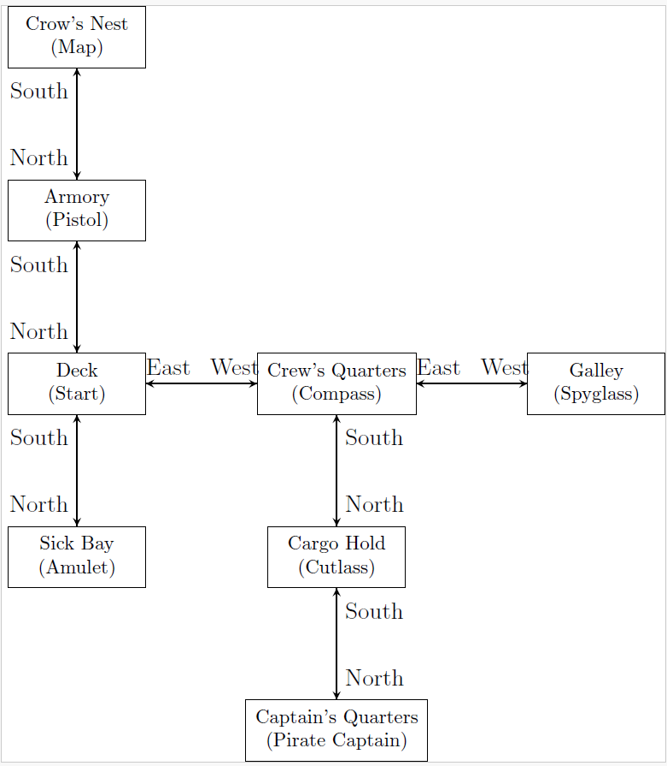

[Type a quote from the document or the summary of an interesting point. You can position the text box anywhere in the document. Use the Drawing Tools tab to change the formatting of the pull quote text box.]